**SDA Lab 12**

**Name:** Hafsa Salman

**Roll no.** 22K-5161

**Example 01**

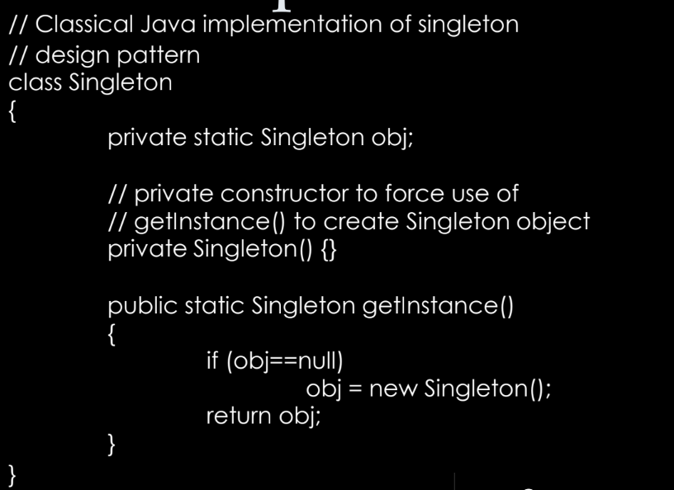

Design Pattern: Singleton

**Example 02**

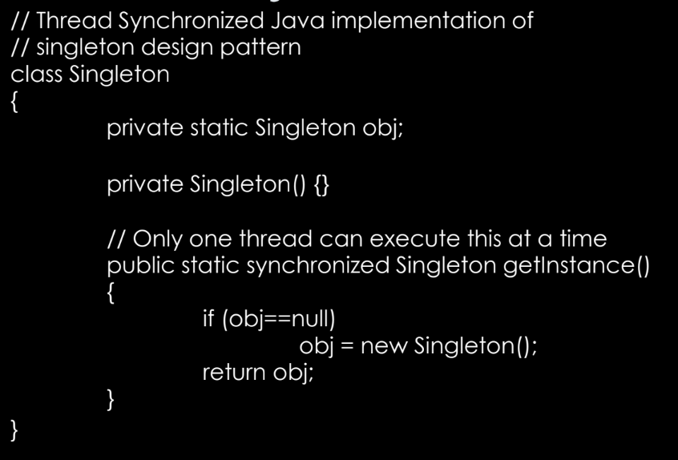

Design Pattern: Singleton

**Example 03**

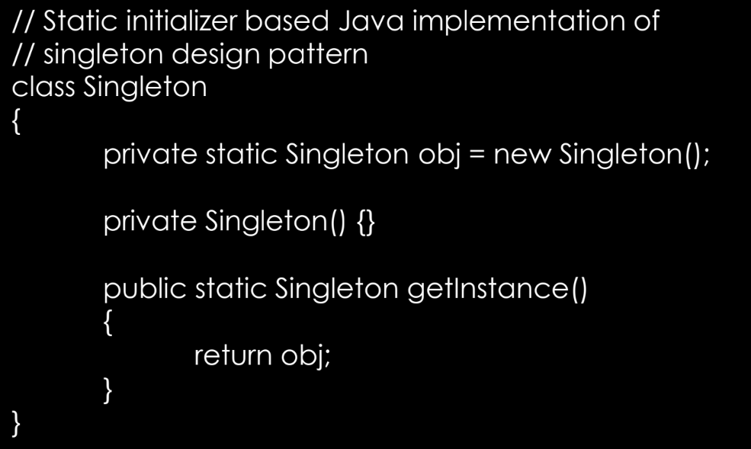

Design Pattern: Singleton

**Example 04**

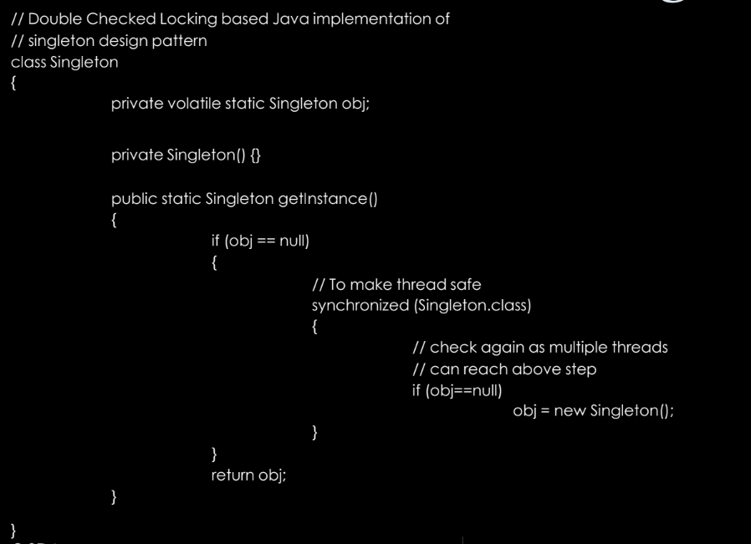

Design Pattern: Singleton

**Example 05**

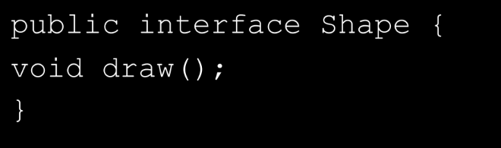

Design Pattern: Factory

**Example 06**

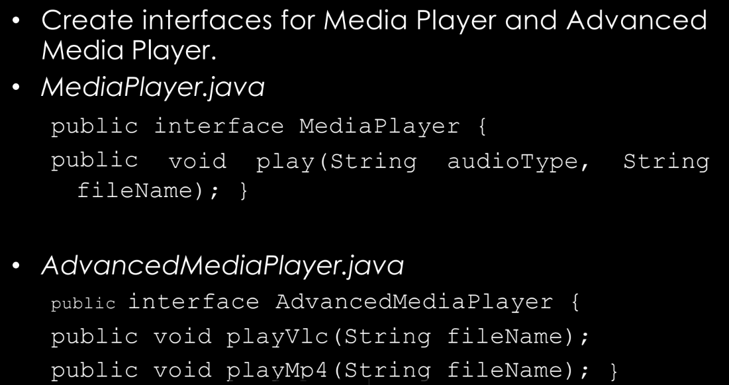

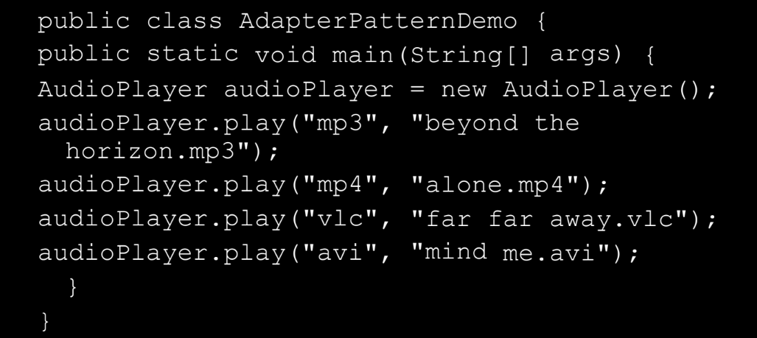

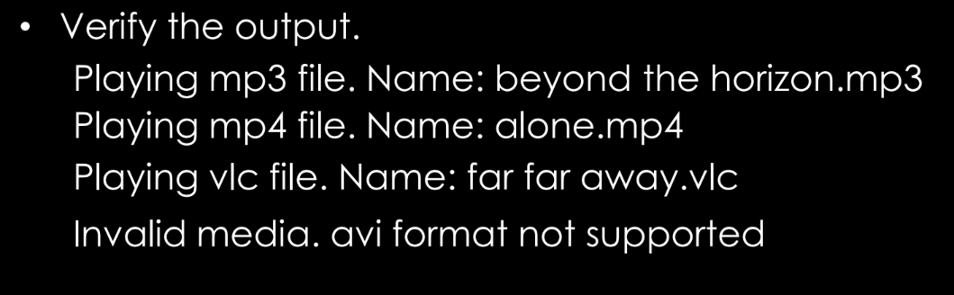

Design Pattern: Adapter